FTP uses two port numbers: 20 and 21. Apply tcp.port==20 and tcp.port==21. Analyze the

result and write down the purposes of these two ports for FTP.

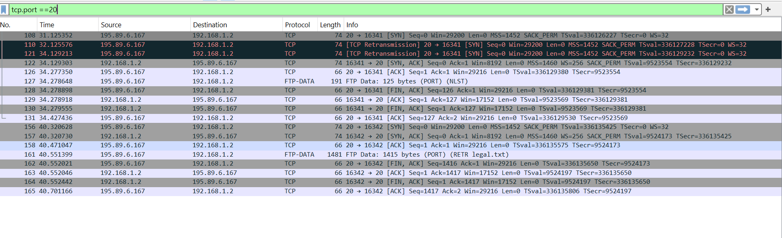

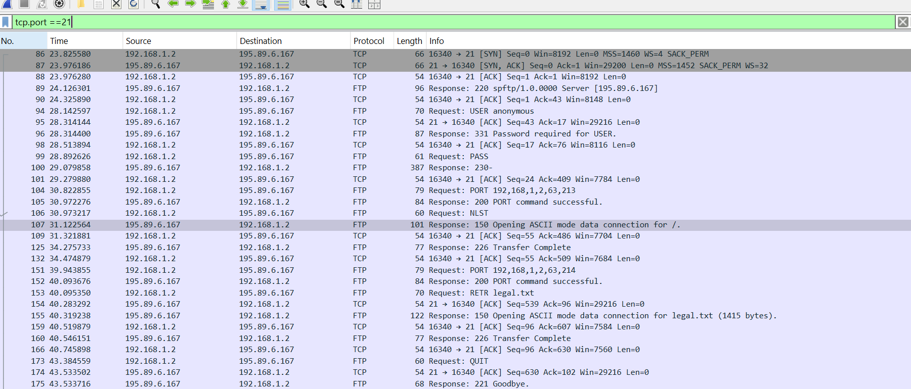

FTP uses control and data channels, each using a separate TCP port.

Port 21 is for the control channel, and port 20 is for the data channel

2. 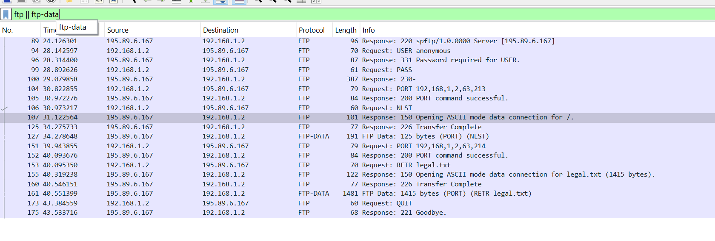

I'll analyze each FTP and FTP-DATA packet in the session to retrieve the file legal.txt, explaining their purpose and relevant response codes:

Packet 89: Server greeting

Response Code: 220

Purpose: FTP server (195.89.6.167) sends initial greeting to client

Packet 94: Client login attempt

Request: USER anonymous

Purpose: Client (192.168.1.2) attempts to log in with anonymous username

Packet 97: Server password request

Response Code: 331

Purpose: Server requests password for anonymous login

Packet 99: Client password submission

Request: PASS

Purpose: Client submits password (likely empty for anonymous login)

Packet 100: Server login success

Response Code: 230

Purpose: Server confirms successful login

Packet 104: Client data connection request

Request: PORT 192,168,1,2,63,213

Purpose: Client asks server to send data to IP 192.168.1.2 on port 16341 (63\*256 + 213)

Packet 105: Server accepts data connection

Response Code: 200

Purpose: Server confirms PORT command successful

Packet 106: Client requests directory listing

Request: NLST

Purpose: Client requests a list of directory contents

Packet 107: Server opens data connection

Response Code: 150

Purpose: Server begins opening ASCII mode data connection for directory listing

Packet 125: Server completes transfer

Response Code: 226

Purpose: Server indicates directory listing transfer is complete

Packet 126: Directory listing data

Protocol: FTP-DATA

Purpose: Actual directory listing data transferred (125 bytes)

Packet 151: Client requests new data connection

Request: PORT 192,168,1,2,63,214

Purpose: Client asks server to send data to IP 192.168.1.2 on port 16342 (63\*256 + 214)

Packet 152: Server accepts new data connection

Response Code: 200

Purpose: Server confirms new PORT command successful

Packet 153: Client requests file retrieval

Request: RETR legal.txt

Purpose: Client requests to download the file "legal.txt"

Packet 155: Server begins file transfer

Response Code: 150

Purpose: Server starts opening ASCII mode data connection for legal.txt (1415 bytes)

Packet 160: Server completes file transfer

Response Code: 226

Purpose: Server indicates file transfer is complete

Packet 161: File data transfer

Protocol: FTP-DATA

Purpose: Actual file data for legal.txt transferred (1415 bytes)

Packet 173: Client ends session

Request: QUIT

Purpose: Client requests to terminate the FTP session

Packet 175: Server acknowledges session end

Response Code: 221

Purpose: Server confirms session termination with goodbye message